|  |  |  |  |  |  |  |
| --- | --- | --- | --- | --- | --- | --- |
| **Document Name** | **Version** | **Status** | **Date** | **Viewable** | **Editable** | **Response** |
| Promotion Provider_SRS_0.1 | Promotion Provider_SRS_0.1  **Added**   * Introduction * Overall description * Functional requirements | Draft | 18-06-2015 | TS, NC, PS | TS, NC | TS |
| Promotion Provider_SRS_0.2 | Promotion Provider_SRS_0.2  **Updated**   * Functional requirements | Draft | 21-06-2015 | TS, NC, PS | TS, NC | TS |
| Promotion Provider_SRS_0.3 | Promotion Provider_SRS_0.3  **Added**   * Use case diagram | Draft | 22-06-2015 | TS, NC, PS | TS, NC | TS |
| Promotion Provider_SRS_0.4 | Promotion Provider_SRS_0.4  **Added**   * Use case description | Draft | 24-06-2015 | TS, NC, PS | TS, NC | TS |
| Promotion Provider_SRS_0.5 | Promotion Provider_SRS_0.5  **Added**   * Software requirement specification | Draft | 28-06-2015 | TS, NC, PS | TS, NC | TS |

Document Designed by

Tanawat Sitthitan  
Nattakit Chaiwongsri  
July 18, 2015   
  
Document Approved by

_______________  
Mr. Phudinan Singkhamfu

August 27, 2014

Table of Content

Chapter1 | Introduction 3

1.1 Purpose 3

1.2 Intended Audience and Reading Suggestions 3

1.3 Software Scope 3

1.4 Operation Environment 4

1.5 Definition, Acronyms and Abbreviation 4

1.5.1 Key Definition 4

1.5.2 Keys Acronyms and Abbreviations 5

Chapter 2 | Overall Description & Requirement 6

2.1 Product Perspective 6

2.2 Product Features 6

Web Server 6

2.3 User Class and Characteristics 8

2.4 Constraints 8

Chapter Three | Functional Requirement 9

3.1 User Requirement Specification 9

3.1.1 Administration (Web Server) 9

3.1.2 Shop owner (Web Server) 10

3.1.3 Guest (Web Server) 10

3.2 System requirement specification 10

3.3 User Requirement Specification with System Requirement Specification. 12

3.3.1 Administration (Web Server) 12

3.3.2 Shop owner (Web Server) 19

3.3.3 Guest (Web Server) 21

Chapter Four | Specific Requirement 22

4.1 Use case Scenario 22

4.1.1 Web server use case diagram 22

4.1.2 Mobile application use case diagram 30

4.2 Use Case Description 30

4.2.1 Web server user case description 30

Chapter Five | Software Requirement Specification 56

6.1 Administrator (Web server) 56

# Chapter1 | Introduction

## Purpose

The purpose of software requirement specification is used to describe the operation of software that will be developed by developers. Software requirement specification will be an agreement between developers and stakeholder. This document is provided for the users and developers to explicit understand the detail of each requirement. The purpose of Promotion Provider, we aim to provide people the easiest way to search for restaurants to go. The project will focus exclusively on the providing promotion and notification when the user gets closer than 20 meters. Also, the SRS document is used in the software design phase, which is lead to consistency between the software product and functional requirement.

## Intended Audience and Reading Suggestions

This Software Requirement specification (SRS) is intended to use for:

1. Developer can read and understand how Promotion Provider works and they can use this   
 document to help them in implementation phrase easier.

2. Customer can read and understand the overall of the system by this document.

3. User can use this document to understanding how use the software and all features.

4. This document using to be a reference for testing system.

## 1.3 Software Scope

Promotion Provider is an application on iOS platform. We develop this application for letting user know the special offer. It can provide a much needed restaurant, and help user to get direction to the restaurant. It is also the simply way to find which restaurant has a promotion. It can help the users make a decision which restaurant is the most appropriate one to go, and it also help saving time that may be wasted during the process of searching for the place. The scope of software has controlled by the user requirements.

## 1.4 Operation Environment

Promotion Provider support only iOS7 on device IPhone4 and iPhones 5, iPod touch. This application is not available without Internet connection and GPS may not accurate in the rainy day.

## 1.5 Definition, Acronyms and Abbreviation

### 1.5.1 Key Definition

* IEEE Institute for Electrical and Electronics Engineers. Biggest global   
   interest group for engineers of different branches and for computer   
   scientists. [IEEE90]
* Requirement (1) A condition or capability needed by a user to solve a problem or   
   achieve an objective. (2) A condition or capability that must be met   
   or possessed by a system or system component to satisfy a contract,   
   standard, specification, or other formally imposed document. (3) A   
   documented representation of a condition or capability as in   
   definition (1) or (2). [IEEE90]
* Feature Transformation of input parameters to output parameters based on   
   a specified algorithm. It describes the functionality of a product in   
   the language of the product. Used for requirements analysis, design,   
   coding, testing or maintenance.[IEEE90]
* Use Case (1) Concept to describe a system based on usage of system   
   resources by its environment. Characterized by an objective set of   
   interactions within and at the borders of that system. (2) Notation   
   from UML for describing a scenario (Usage approach, operational   
   scenario) from the perspective of its users. [IEEE90]
* Web A computer software application that is coded in a browser   
  Application supported and reliant on a common web browser to render the   
   application executable.
* Software The application of a systematic, disciplined, quantifiable approach to   
  Engineering the development, operation, and maintenance of software; that is,   
   the application of engineering to software.” [IEEE90]
* Specification Precise description of an activity or work product which serves as   
   basis or input for further activities or work product. A specification   
   can comprise requirements to a product and how they will be   
   solved. Different parts of a specification (e.g., what is to be done,   
   how it will be done) must not be mixed.[IEEE90]

### 1.5.2 Keys Acronyms and Abbreviations

|  |  |
| --- | --- |
| Key Acronyms | Abbreviation |
| IEEE | Institute of Electrical and Electronics Engineers |
| UC-WSXX | Use Case Diagram web service number XX |
| UC-MAXX | Use Case Diagram Mobile Application number XX |
| SRS-XX | Software Requirement Specification number XX |
| URS-XX | User Requirement Specification number XX |
| UI | User Interface |
| UC | Use case Diagram |
| AD | Activity Diagram |

# Chapter 2 | Overall Description & Requirement

## 2.1 Product Perspective

Promotion Provider is an application on iOS platform. This application allows a user conveniently find a special offer or promotion from the restaurant or hotel, as well as get the notification while the user gets close to the restaurant. It also provides the route and distance to the restaurant. It will advise a famous restaurant to the user without any typing. It can receive information from the owners who want to promote their business. It can receive feedback and review from the user. The user allows to share and check in to show their friend. We will develop this application to be guidance for the tourist who use iPhones and is controlled the quality of software following the ISO29110.

## 2.2 Product Features

This section is outlines all functions of Promotion Provider.

### Web Server

Web server provided shops, promotions to iOS application. Administrator can mange all information included shops and promotions. Shop owner can manage their own promotions and their own account.

Admin able to:

* Log in
* Log out
* Manage account
  + Add account
  + Edit account
  + Delete account
* Manage Promotion
  + Add promotion
  + Edit promotion
  + Delete promotion
* Accept register request
* Reject register request
* Search
  + Search account by shop name
  + Search account by email
  + Search account by id
  + Search promotion by name
  + Search promotion by id
  + Search promotion by shop name
  + Search user’s logs by function
  + Search user’s logs by shop name
  + Search user’s logs by email
* View
  + Shop list
  + Promotion list
  + Shop information
  + Promotion information
  + User’s action logs
  + Redeem code list
  + Redeem code information
  + Mobile user list
  + Mobile user information
* Change password

Shop owner able to:

* Log in
* Log out
* Mange promotion
  + Add promotion
  + Edit promotion
  + Delete promotion
* Change password
* Submit redeem code

Guest able to:

* Sent register request

## 2.3 User Class and Characteristics

Promotion Provider is an iOS mobile application on iPhone, it provides the promotions for users. Admin should be able to manage all information on web server. Shop owner should be able to creates promotions on the web server. Mobile user should be received a notification when they get close enough to the restaurant where has the promotion.

## 2.4 Constraints

* CO-01: The web server can not provides information to mobile application without internet connection.
* CO-02: Mobile application supports iOS7 or later on device iPhone4 and iPhone5, iPhone 6 and iPod touch.
* CO-03: Mobile application not available without Internet connection.
* CO-04: Mobile application requires to turn on location service on the user mobile for identifying the user location.

# Chapter Three | Functional Requirement

## 3.1 User Requirement Specification

### 3.1.1 Administration (Web Server)

* **URS-01:** Admin can login to web server
* **URS-02**: Admin can logout from web server
* **URS-03**: Admin can add shop owner account
* **URS-04**: Admin can edit shop owner account
* **URS-05**: Admin can delete shop owner account
* **URS-06**: Admin can add promotion to shop owner
* **URS-07**: Admin can edit shop owner promotion
* **URS-08**: Admin can delete shop owner promotion
* **URS-09**: Admin can accept register request
* **URS-10**: Admin can reject register request
* **URS-11**: Admin can view account list
* **URS-12**: Admin can view account information
* **URS-13**: Admin can view promotion list
* **URS-14**: Admin can view promotion information
* **URS-15**: Admin can view user logs
* **URS-16**: Admin can view redeem code list
* **URS-17**: Admin can view redeem code information
* **URS-18**: Admin can view mobile user list
* **URS-19**: Admin can view mobile user information
* **USR-20**: Admin can search account by shop name
* **URS-21**: Admin can search account by email
* **URS-22**: Admin can search account by id
* **URS-23**: Admin can search promotion by name
* **URS-24**: Admin can search promotion by id
* **URS-25**: Admin can search promotion by shop name
* **URS-26**: Admin can search logs by function
* **URS-27**: Admin can search logs by shop name
* **URS-28**: Admin can search logs by email
* **URS-29**: Admin can change password

### 3.1.2 Shop owner (Web Server)

* **URS-30**: Shop owner can add promotion
* **URS-31**: Shop owner can edit promotion
* **URS-32**: Shop owner can delete promotion
* **URS-33**: Shop owner can update their profile
* **URS-34**: Shop owner can change password
* **URS-35**: Shop owner can log in to web server
* **URS-36**: Shop owner can log out from web server
* **URS-37**: Shop owner can submit redeem code
* **URS-38**: Shop owner can submit redeem code
* **URS-39**: Shop owner can view promotion list

### 3.1.3 Guest (Web Server)

* **URS-40**: Guest can sent register request

## 3.2 System requirement specification

* **SRS-01**: The system shall provides user interface to log in.
* **SRS-02**: The system shall verifies email and password.
* **SRS-03**: The system shall keeps user’s session.
* **SRS-04**: The system shall destroys session.
* **SRS-05**: The system shall provides user interface to logout.
* **SRS-06**: The system shall provides add account user interface to add new shop owner account.
* **SRS-07**: The system shall checks not available email in database.
* **SRS-08**: The system shall provides user interface to delete shop owner
* **SRS-09**: The system shall provides user interface to delete promotion
* **SRS-10**: The system shall provides user interface to accept register request
* **SRS-11**: The system shall checks all input required.
* **SRS-12**: The system shall records new account into database.
* **SRS-13**: The system shall provides edit account page to edit shop owner account.
* **SRS-14**: The system shall updates new input information to database.
* **SRS-15**: The system shall verifies redeem code
* **SRS-16**: The system shall provides user list.
* **SRS-17**: The system shall updates account status.
* **SRS-18**: The system shall provides add promotion user interface to add new promotion.
* **SRS-19**: The system shall checks consistency between start date and end date.
* **SRS-20**: The system shall checks all input required.
* **SRS-21**: The system shall records new promotion into database.
* **SRS-22**: The system shall provides edit promotion user interface to edit promotion.
* **SRS-24**: The system shall provides promotion list.
* **SRS-25**: The system shall updates promotion status.
* **SRS-26**: The system shall creates a directory for account
* **SRS-27**: The system shall creates a sub directory for profile
* **SRS-28**: The system shall uploads image to directory.
* **SRS-29**: The system shall gets file path.
* **SRS-30**: The system shall creates a sub directory for promotion
* **SRS-31**: The system shall removes image in directory.
* **SRS-32**: The system shall checks there is no image in directory
* **SRS-33**: The system shall removes directory
* **SRS-34**: The system shall removes image path in database.
* **SRS-35**: The system shall updates user interface
* **SRS-36**: The system shall records user action in database
* **SRS-37**: The system shall selects data from database
* **SRS-38**: The system shall return account list
* **SRS-39**: The system shall updates register request status
* **SRS-40**: The system shall provides user interface to reject register request
* **SRS-41**: The system shall gets data from database
* **SRS-42**: The system shall provides user interface to show account list
* **SRS-43**: The system shall provides user interface to show account information
* **SRS-44**: The system shall provides user interface to show promotion list
* **SRS-45**: The system shall provides user interface to show promotion information
* **SRS-46**: The system shall provides user interface to show user logs
* **SRS-47**: The system shall provides user interface to show redeem code list
* **SRS-48**: The system shall provides user interface to show redeem code information
* **SRS-49**: The system shall provides user interface to show mobile user list
* **SRS-50**: The system shall provides user interface to show mobile user information
* **SRS-51**: The system shall finds account by shop name in database
* **SRS-52**: The system shall finds account by shop email in database
* **SRS-53**: The system shall finds account by shop id in database
* **SRS-54**: The system shall return promotion list
* **SRS-55**: The system shall finds promotion by name in database
* **SRS-56**: The system shall finds promotion by id in database
* **SRS-57**: The system shall finds promotion by shop name in database
* **SRS-58**: The system shall finds logs by function in database
* **SRS-59**: The system shall find slogs by shop name in database
* **SRS-60**: The system shall return logs list
* **SRS-61**: The system shall finds logs by email in database
* **SRS-62**: The system shall verifies password and confirm password
* **SRS-63**: The system shall deducts mobile user redeem point
* **SRS-64**: The system shall updates redeem code status

## 3.3 User Requirement Specification with System Requirement Specification.

### 3.3.1 Administration (Web Server)

**URS-01: Admin can login to web server**

Admin can log in to system by input email and password. The operations in system mostly required to log in to identify user role and user information.

**SRS-01**: The system shall provides user interface to log in.  
**SRS-02**: The system shall verifies email and password.  
**SRS-03**: The system shall keeps user’s session.

**URS-02: Admin can logout from web server**

Admin can log out from server. When the admin log out they can’t do anything with system

**SRS-05**: The system shall provides user interface to logout.  
**SRS-04**: The system shall destroys session.

**URS-03: Admin can add shop owner account**

Admin can add or create shop owner account to system. Admin have to input shop owner information to the system. After admin completed add shop owner account, that account will allowed to log in to system.

**SRS-06**: The system shall provides add account page to add new shop owner account.  
**SRS-07**: The system shall checks not available email in database.  
**SRS-26**: The system shall creates a directory for account  
**SRS-27**: The system shall creates a sub directory for profile  
**SRS-28**: The system shall upload image to directory.  
**SRS-29**: The system shall gets file path.  
**SRS-11**: The system shall checks all input required.  
**SRS-12**: The system shall records new account into database.

**URS-04: Admin can edit user account**

Admin can edit user account in system by update existing information or input new information. Email is the only one information that can not be changed.

**SRS-13**: The system shall provides edit account page to edit user account.  
**SRS-11**: The system shall checks all input required.  
**SRS-14**: The system shall updates new input information to database.

**URS-05: Admin can delete user account**

Admin can delete unwanted account in system. After admin deleted account, the account will not allowed to login to system anymore and account can’t do any thing with system.

**SRS-08**: The system shall provides user interface to delete user

**SRS-31**: The system shall removes image in directory.  
**SRS-32**: The system shall checks there is no image in directory  
**SRS-33**: The system shall removes directory  
**SRS-34**: The system shall removes image path in database.  
**SRS-17**: The system shall updates account status.  
**SRS-35**: The system shall update user interface

**URS-06: Admin can add promotion to shop owner**

Admin can add promotion to shop owner account. Admin have to input promotion information. When admin has added promotion to shop owner account, the promotion will appear in shop owner promotion.

**SRS-18**: The system shall provides add promotion user interface to add new promotion.  
**SRS-19**: The system shall checks consistency between start date and end date.  
**SRS-30**: The system shall creates a sub directory for promotion  
**SRS-28**: The system shall upload image to directory.  
**SRS-29**: The system shall gets file path.  
**SRS-20**: The system shall checks all input required.  
**SRS-21**: The system shall records new promotion into database.

**URS-07: Admin can edit shop owner promotion**

Admin can edit shop owner promotion in system by update existing information or input new information.

**SRS-22**: The system shall provides edit promotion user interface to edit promotion.  
**SRS-19**: The system shall checks consistency between start date and end date.  
**SRS-20**: The system shall checks all input required.  
**SRS-21**: The system shall records new promotion into database.

**URS-08: Admin can delete shop owner promotion**

Admin can delete unwanted promotion in shop owner account. When promotion has been deleted, it will disappear from shop owner account.

**SRS-09**: The system shall provides user interface to delete promotion  
**SRS-31**: The system shall removes image in directory.  
**SRS-32**: The system shall checks there is no image in directory  
**SRS-33**: The system shall removes directory  
**SRS-34**: The system shall removes image path in database.  
**SRS-25**: The system shall updates promotion status.  
**SRS-35**: The system shall update user interface

**URS-09: Admin can accept register request**

Admin can accept or approve register request from guest. After admin accepted request, guest can login to system.

**SRS-10**: The system shall provides user interface to accept register request  
**SRS-39**: The system shall update register request status  
**SRS-12**: The system shall records new account into database.

**URS-10: Admin can reject register request**

Admin can reject register request from guest. This operator can not undo.

**SRS-40**: The system shall provides user interface to reject register request  
**SRS-39**: The system shall update register request status

**URS-11: Admin can view account list**

Admin can view user account list in system.  
**SRS-41**: The system shall gets data from database  
**SRS-42**: The system shall provide user interface to show account list

**URS-12: Admin can view account information**

Admin can view account information included image.  
**SRS-41**: The system shall gets data from database  
**SRS-43**: The system shall provide user interface to show account information

**URS-13: Admin can view promotion list**

Admin can view promotion list in system.  
**SRS-41**: The system shall gets data from database  
**SRS-44**: The system shall provide user interface to show promotion list

**URS-14: Admin can view promotion information**

Admin can view promotion information included image.

**SRS-41**: The system shall gets data from database  
**SRS-45**: The system shall provide user interface to show promotion information

**URS-15: Admin can view user logs**

Admin can view user logs.

**SRS-41**: The system shall gets data from database  
**SRS-46**: The system shall provide user interface to show user logs

**URS-16: Admin can view redeem code list**

Admin can view redeem code list in system.

**SRS-41**: The system shall gets data from database  
**SRS-47**: The system shall provides user interface to show redeem code list

**URS-17: Admin can view redeem code information**

Admin can view redeem code information.

**SRS-41**: The system shall gets data from database  
**SRS-41**: The system shall gets data from database

**URS-18: Admin can view mobile user list**

Admin can view mobile user list

**SRS-41**: The system shall gets data from database  
**SRS-49**: The system shall provides user interface to show mobile user list

**URS-19: Admin can view mobile user information**

Admin can view mobile user information

**SRS-41**: The system shall gets data from database  
**SRS-50**: The system shall provides user interface to show mobile user information

**USR-20: Admin can search account by shop name**

Admin can search account by input shop name

**SRS-51**: The system shall find account by shop name in database  
**SRS-38**: The system shall return account list  
**SRS-42**: The system shall provides user interface to show account list

**URS-21: Admin can search account by email**

Admin can search account by input email

**SRS-52**: The system shall find account by shop email in database  
**SRS-38**: The system shall return account list  
**SRS-42**: The system shall provides user interface to show account list

**URS-22: Admin can search account by id**

Admin can search account by input id

**SRS-53**: The system shall find account by shop id in database  
**SRS-38**: The system shall return account list  
**SRS-42**: The system shall provides user interface to show account list

**URS-23: Admin can search promotion by name**

Admin can search promotion by input promotion name

**SRS-55**: The system shall find promotion by name in database  
**SRS-54**: The system shall return promotion list  
**SRS-44**: The system shall provides user interface to show promotion list

**URS-24: Admin can search promotion by id**

Admin can search promotion by input promotion id

**SRS-56**: The system shall find promotion by id in database  
**SRS-54**: The system shall return promotion list  
**SRS-44**: The system shall provides user interface to show promotion list

**URS-25: Admin can search promotion by shop name**

Admin can search promotion by input shop name

**SRS-57**: The system shall find promotion by shop name in database  
**SRS-54**: The system shall return promotion list  
**SRS-44**: The system shall provides user interface to show promotion list

**URS-26: Admin can search logs by function**

Admin can search user logs by function

**SRS-58**: The system shall find logs by function in database  
**SRS-51**: The system shall return logs list  
**SRS-46**: The system shall provides user interface to show user logs

**URS-27: Admin can search logs by shop name**

Admin can search user logs by shop name

**SRS-50**: The system shall find logs by shop name in database  
**SRS-51**: The system shall return logs list  
**SRS-46**: The system shall provides user interface to show user logs

**URS-28: Admin can search logs by email**

Admin can search user logs by email

**SRS-52**: The system shall find logs by email in database  
**SRS-51**: The system shall return logs list  
**SRS-46**: The system shall provides user interface to show user logs

**URS-29: Admin can change password**

Admin can change their password

**SRS-53**: The system shall verify password and confirm password  
**SRS-14**: The system shall updates new input information to database

### 3.3.2 Shop owner (Web Server)

**URS-30: Shop owner can add promotion**

Shop owner can add their own promotion. The shop owner have to input promotion information. When shop owner has added promotion then the promotion will appear on their shop.

**SRS-18**: The system shall provides add promotion user interface to add new promotion  
**SRS-19**: The system shall checks consistency between start date and end date  
**SRS-30**: The system shall creates a sub directory for promotion  
**SRS-28**: The system shall upload image to directory  
**SRS-29**: The system shall gets file path  
**SRS-20**: The system shall checks all input required  
**SRS-21**: The system shall records new promotion into database

**URS-31: Shop owner can edit promotion**

Shop owner can edit their own promotion. This operation, shop owner can update the existing information or shop owner might input new information included promotion image.

**SRS-22**: The system shall provides edit promotion user interface to edit promotion  
**SRS-19**: The system shall checks consistency between start date and end date  
**SRS-20**: The system shall checks all input required.  
**SRS-21**: The system shall records new promotion into database.

**URS-32: User can delete promotion**

Shop owner can delete unwanted promotion. When shop owner has deleted their promotion, the deleted promotion will disappear from shop owner account. This operation can not undo.

**SRS-09**: The system shall provides user interface to delete promotion  
**SRS-31**: The system shall removes image in directory  
**SRS-32**: The system shall checks there is no image in directory  
**SRS-33**: The system shall removes directory  
**SRS-34**: The system shall removes image path in database  
**SRS-25**: The system shall updates promotion status  
**SRS-35**: The system shall update user interface

**URS-33: Shop owner can update their profile**

Shop owner can edit their own profile. This operation, shop owner can update the existing information or user might input new information included shop image

**SRS-13**: The system shall provides edit account page to edit user account  
**SRS-11**: The system shall checks all input required  
**SRS-14**: The system shall updates new input information to database

**URS-34: Shop owner can change password**

Shop owner can change their password

**SRS-53**: The system shall verify password and confirm password  
**SRS-14**: The system shall updates new input information to database

**URS-35: Shop owner can log in to web server** Shop owner can log in to system by input email and password. The operations in system mostly required to log in to identify user role and user information.

**SRS-01**: The system shall provides user interface to log in  
**SRS-02**: The system shall verifies email and password  
**SRS-03**: The system shall keeps user’s session

**URS-36: Shop owner can log out from web server** Shop owner can log out from server. When the shop owner log out they can’t do anything with system

**SRS-05**: The system shall provides user interface to logout  
**SRS-04**: The system shall destroys session

**URS-37: Shop owner can submit redeem code**

Shop owner can submit redeem code which is get from mobile user. This operation use to deduct mobile user redeem point when they use redeem code.

**SRS-15**: The system shall verifies redeem code  
**SRS-54**: The system shall deduct mobile user redeem point  
**SRS-55**: The system shall update redeem code status

**URS-38: Shop owner can view promotion list**

Shop owner can view promotion list

**SRS-41**: The system shall gets data from database  
**SRS-44**: The system shall provide user interface to show promotion list

**URS-39: Shop owner can view promotion information**

Shop owner can view promotion information

**SRS-41**: The system shall gets data from database  
**SRS-45**: The system shall provide user interface to show promotion information

### 3.3.3 Guest (Web Server)

**URS-40: Guest can sent register request**

Guest can sent register request to admin. Guest have to input the account information.

# Chapter Four | Specific Requirement

## 4.1 Use case Scenario

### 4.1.1 Web server use case diagram

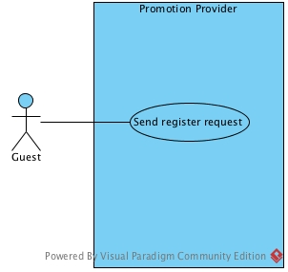

Figure 3.1 Guest use case

Figure 3.1 shows actor is guest. The guest can only send register request to system. When guest send register request to system, they have to input the information that use for verify themselves by admin.

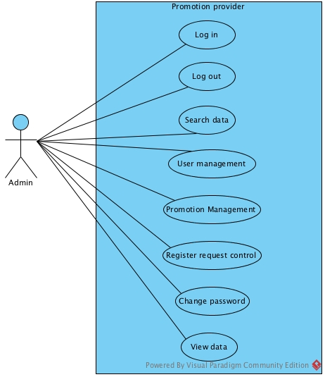

Figure 3.2 Admin user case

Figure 3.2 shows actor is admin. The admin can log in to system, log out from system. Admin also can search data which are user account, promotion, logs. The promotion management, User management, register request control are admin abilities. Admin able to view data which are user list, user information, promotion list, promotion information and logs.

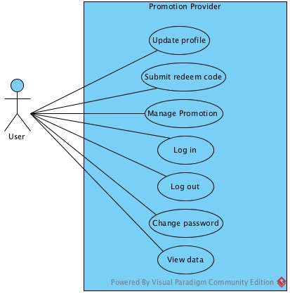

Figure 3.3 User use case

Figure 3.3 shows actor is user. User able to update profile, submit redeem code, log in, log out and change password. User also can manage promotion which are add, edit and delete promotion. User can view promotion list and promotion information.

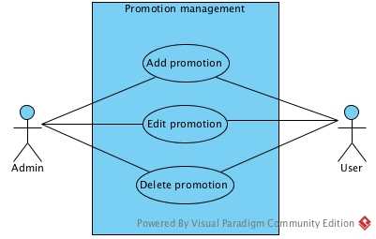

Figure 3.4 Promotion management sub-system

Figure 3.4 shows promotion management sub-system which has two actor, admin and user. Admin can add promotion to user account, edit use promotion and delete unwanted user promotion. User can add promotion to their account, edit their promotion and delete the promotion. Admin can mage all promotion in system but user can manage only their own promotion.

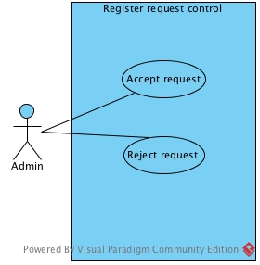

Figure 3.5 Register request control sub-system

Figure 3.5 shows register request control sub-system which has admin as an actor. Admin can control register request by accept request or reject request.

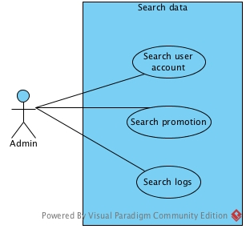

Figure 3.6 Search data sub-system

Figure 3.6 shows search data sub-system which has admin as an actor. Admin can search for user account by name, id or email. Admin able to search promotion by name, id or shop name. The admin also can search logs by function or account email.

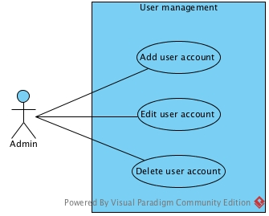

Figure 3.7 User management sub-system

Figure 3.7 shows user management sub-system which has admin as an actor. Admin can manage user account which are add, edit and delete. The add operation required admin to input user information.

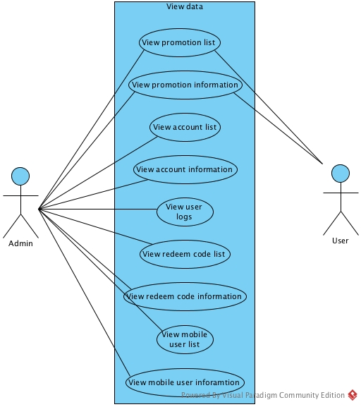

Figure 3.8 View data sub-system

Figure 3.8 shows view data sub-system. Admin actor can view every data or information in system which are promotion, account, logs, redeem code and mobile user. In the other hand user actor can view only their own promotion data.

### 4.1.2 Mobile application use case diagram

## 4.2 Use Case Description

### 4.2.1 Web server user case description

|  |  |  |  |
| --- | --- | --- | --- |
| Use case ID: | UC-WS01 | | |
| Use case name: | Send register request | | |
| Created by: | Tanawat | **Last update by:** | Tanawat |
| Created date: | June 22, 2015 | **Last update date:** | June 22, 2015 |
|  |  | | |
| Actor(s): | Guest | | |
| Description: | Guest send register request to admin to become a user in web server. | | |
| Trigger: | None | | |
| Pre condition: | None | | |
| Post condition: | 1. Register request appear to admin | | |
| Normal Flow: | 1. Guest open web server 2. Guest click “Join WAP” button 3. System provides user interface to get shop information 4. Guest input shop information 5. System check available email 6. System records request in database 7. System records logs 8. System redirect guest to index page | | |
| Alternative Flow: | 1. If guest input not available email, system will not record request to database 2. System shows “not available email” message 3. Allow guest go back to step#3 | | |
| Priority: | 2 | | |
| Exception: | None | | |

|  |  |  |  |
| --- | --- | --- | --- |
| Use case ID: | UC-WS02 | | |
| Use case name: | Log in | | |
| Created by: | Tanawat | **Last update by:** | Tanawat |
| Created date: | June 22, 2015 | **Last update date:** | June 22, 2015 |
|  |  | | |
| Actor(s): | Admin, Shop owner | | |
| Description: | Admin or shop owner log in to web server by using email and password. Mostly operations required admin to log in to identify themselves. | | |
| Trigger: | None | | |
| Pre condition: | 1. Admin or shop owner must have account in system 2. Admin or shop owner must clicks the “Sign in” button | | |
| Post condition: | 1. Admin or shop owner logged in to system 2. System store admin’s session or user’s session | | |
| Normal Flow: | 1. Admin or shop owner open web server 2. System provides user interface to get input email and password 3. Admin or shop owner input email and password 4. Admin or shop owner click “Sign in” button 5. System verifies matched email and password from database 6. System store admin’s session or user’s session 7. System records logs 8. System redirect admin to admin dashboard page or redirect shop owner to shop owner dashboard page | | |
| Alternative Flow: | 1. If admin email and password are invalid, admin will not allowed to log in to web server 2. System shows “Invalid email or password” message 3. Allow admin or shop owner go back to step#2 | | |
| Priority: | 1 | | |
| Exception: | None | | |

|  |  |  |  |
| --- | --- | --- | --- |
| Use case ID: | UC-WS03 | | |
| Use case name: | Log out | | |
| Created by: | Tanawat | **Last update by:** | Tanawat |
| Created date: | June 24, 2015 | **Last update date:** | June 24, 2015 |
|  |  | | |
| Actor(s): | Admin, Shop owner | | |
| Description: | Admin or shop owner log out from web server. After admin or user logged out, they can’t do anything with system | | |
| Trigger: | - | | |
| Pre condition: | 1. Admin or shop owner logged in | | |
| Post condition: | 1. System destroy session 2. Admin or shop owner logged out from server | | |
| Normal Flow: | 1. Admin or shop owner click their “email” account menu at top right 2. Admin or shop owner click “log out” button 3. System destroy session 4. System records logs 5. System redirect admin or shop owner to index page | | |
| Alternative Flow: | None | | |
| Priority: | 2 | | |
| Exception: | None | | |

|  |  |  |  |
| --- | --- | --- | --- |
| Use case ID: | UC-WS04 | | |
| Use case name: | Change password | | |
| Created by: | Tanawat | **Last update by:** | Tanawat |
| Created date: | June 24, 2015 | **Last update date:** | June 24, 2015 |
|  |  | | |
| Actor(s): | Admin, Shop owner | | |
| Description: | Admin or shop owner change their password. This operation required admin and shop owner input new password and confirm new password. | | |
| Trigger: | None | | |
| Pre condition: | 1. Admin or shop owner logged in to system | | |
| Post condition: | 1. Admin or shop owner changed password | | |
| Normal Flow: | 1. Admin or shop owner click their “email” account menu at top right 2. Admin or shop owner click “change password” button 3. System provides user interface to change password 4. Admin or shop owner input new password and confirm new password 5. System verifies matched new password and confirm new password 6. System updated new password in database 7. System records logs 8. System records logs 9. System redirect admin or user to dashboard page | | |
| Alternative Flow: | 1. If admin or shop owner input not matched new password and new confirm password, system will not allow them to change password 2. System shows “password not matched” message 3. Allow admin and shop owner go back to step#3 | | |
| Priority: | 2 | | |
| Exception: | None | | |

|  |  |  |  |
| --- | --- | --- | --- |
| Use case ID: | UC-WS05 | | |
| Use case name: | Update profile | | |
| Created by: | Tanawat | **Last update by:** | Tanawat |
| Created date: | June 24, 2015 | **Last update date:** | June 24, 2015 |
|  |  | | |
| Actor(s): | Shop owner | | |
| Description: | Shop owner update profile. This operation will provide existing information to shop information. Shop owner probably edit it or enter new information. Email is the only one information that system not allowed shop owner to change it. | | |
| Trigger: | None | | |
| Pre condition: | 1. Shop owner must logged in as user role | | |
| Post condition: | 1. Shop owner changed their profile | | |
| Normal Flow: | 1. Shop owner clicks “email” account menu at top right 2. Shop owner clicks “Edit profile” button 3. System provides user interface with existing information to get input new information 4. System provides Google map to get latitude and longitude 5. Shop owner input shop new information 6. System verified all input required 7. System updated new shop owner profile to database 8. System records logs 9. System redirect shop owner to dashboard page | | |
| Alternative Flow: | 1. If shop owner not input all required field, system not allowed shop owner to edit profile 2. System shows “input required” message 3. Shop owner allow to go back to step#5 | | |
| Priority: | 3 | | |
| Exception: | 1. System fails to retrieve coordinates and map data due to Google API that provided from Google | | |

|  |  |  |  |
| --- | --- | --- | --- |
| Use case ID: | UC-WS06 | | |
| Use case name: | Submit redeem code | | |
| Created by: | Tanawat | **Last update by:** | Tanawat |
| Created date: | June 24, 2015 | **Last update date:** | June 24, 2015 |
|  |  | | |
| Actor(s): | Shop owner | | |
| Description: | Shop owner submit redeem code from mobile user to deduct mobile user’s redeem point in system. | | |
| Trigger: | None | | |
| Pre condition: | 1. Shop owner must logged in as user role | | |
| Post condition: | 1. Shop owner submitted redeem code 2. System deducted mobile user’s redeem point | | |
| Normal Flow: | 1. Shop owner clicks “Submit redeem code” 2. System provides user interface to get input redeem code 3. Shop owner input redeem code 4. System verifies matched redeem code 5. System deduct mobile user’s redeem point 6. System records logs 7. System redirect shop owner to redeem code list page | | |
| Alternative Flow: | 1. If shop owner input invalid redeem code, system not allowed shop owner to submit redeem code. 2. System shows “Invalid redeem code” message 3. Allow show owner to go back to step#2 | | |
| Priority: | 2 | | |
| Exception: | None | | |

|  |  |  |  |
| --- | --- | --- | --- |
| Use case ID: | UC-WS07 | | |
| Use case name: | Add promotion | | |
| Created by: | Tanawat | **Last update by:** | Tanawat |
| Created date: | June 24, 2015 | **Last update date:** | June 24, 2015 |
|  |  | | |
| Actor(s): | Admin, Shop owner | | |
| Description: | Admin or shop owner add promotion. This operation required admin or shop owner input promotion information | | |
| Trigger: | None | | |
| Pre condition: | 1. Admin or shop owner logged in | | |
| Post condition: | 1. Admin or shop owner added promotion | | |
| Normal Flow: | 1. Admin or shop owner clicks “Add promotion” button 2. System provides user interface to get input promotion information 3. Admin or shop owner input promotion information 4. System verifies all input required 5. System verifies start date and end date 6. System add promotion to database 7. System records logs 8. System redirect admin or shop user to promotion list page | | |
| Alternative Flow: | 1. If admin or shop owner not input all required filed, system not allowed admin or shop owner to add promotion 2. System shows “Input required” message 3. Allow admin or shop owner to go back to step#3 4. If admin or shop owner input start date greater than end date, system not allowed admin or shop owner to add promotion 5. System shows “Invalid start date and end date” message 6. Allow admin or shop owner to go back to step#2 | | |
| Priority: | 2 | | |
| Exception: | None | | |

|  |  |  |  |
| --- | --- | --- | --- |
| Use case ID: | UC-WS08 | | |
| Use case name: | Edit promotion | | |
| Created by: | Tanawat | **Last update by:** | Tanawat |
| Created date: | June 24, 2015 | **Last update date:** | June 24, 2015 |
|  |  | | |
| Actor(s): | Admin, Shop owner | | |
| Description: | Admin or shop owner edit promotion. System will provides existing information to admin or shop information then admin or shop owner probably edit the existing information or input new information | | |
| Trigger: | None | | |
| Pre condition: | 1. Admin or shop owner logged in 2. The promotion must be in system | | |
| Post condition: | 1. Admin or shop owner edited promotion | | |
| Normal Flow: | 1. Admin or shop owner clicks “Edit” button 2. System provides user interface with existing information to edit promotion 3. Admin or shop owner edit or input new information 4. System verifies all input required 5. System update promotion in database 6. System records logs 7. System redirect admin or shop owner to promotion list page | | |
| Alternative Flow: | 1. If admin or shop owner input start date greater than end date, system not allowed admin or shop owner to add promotion 2. System shows “Invalid start date and end date” message 3. Allow admin or shop owner to go back to step#2 | | |
| Priority: | 2 | | |
| Exception: | None | | |

|  |  |  |  |
| --- | --- | --- | --- |
| Use case ID: | UC-WS09 | | |
| Use case name: | Delete promotion | | |
| Created by: | Tanawat | **Last update by:** | Tanawat |
| Created date: | June 24, 2015 | **Last update date:** | June 24, 2015 |
|  |  | | |
| Actor(s): | Admin, Shop owner | | |
| Description: | Admin or shop owner delete promotion in system | | |
| Trigger: | None | | |
| Pre condition: | 1. Admin or shop owner logged in 2. The promotion must be in system | | |
| Post condition: | 1. Admin or shop owner deleted promotion | | |
| Normal Flow: | 1. System provides user interface to delete promotion 2. Admin or shop owner clicks “delete” button 3. System delete promotion in database 4. System records logs | | |
| Alternative Flow: | None | | |
| Priority: | 2 | | |
| Exception: | None | | |

|  |  |  |  |
| --- | --- | --- | --- |
| Use case ID: | UC-WS10 | | |
| Use case name: | Reject request | | |
| Created by: | Tanawat | **Last update by:** | Tanawat |
| Created date: | June 24, 2015 | **Last update date:** | June 24, 2015 |
|  |  | | |
| Actor(s): | Admin | | |
| Description: | Admin reject register request from guest | | |
| Trigger: | None | | |
| Pre condition: | 1. Register request must be in system 2. Admin must logged in as admin role | | |
| Post condition: | 1. Admin rejected register request | | |
| Normal Flow: | 1. System provides user interface to reject request 2. Admin clicks “reject” button 3. System request confirm 4. Admin confirm reject request 5. System rejected request 6. System records logs | | |
| Alternative Flow: | None | | |
| Priority: | 2 | | |
| Exception: | None | | |

|  |  |  |  |
| --- | --- | --- | --- |
| Use case ID: | UC-WS11 | | |
| Use case name: | Reject request | | |
| Created by: | Tanawat | **Last update by:** | Tanawat |
| Created date: | June 24, 2015 | **Last update date:** | June 24, 2015 |
|  |  | | |
| Actor(s): | Admin | | |
| Description: | Admin accept register request from guest | | |
| Trigger: | None | | |
| Pre condition: | 1. Register request must be in system 2. Admin must logged in as admin role | | |
| Post condition: | 1. Admin accept register request 2. The accepted guest can log in to system | | |
| Normal Flow: | 1. System provides user interface to accept request 2. Admin accept request 3. System record new shop owner account in database 4. System records logs | | |
| Alternative Flow: | None | | |
| Priority: | 2 | | |
| Exception: | None | | |

|  |  |  |  |
| --- | --- | --- | --- |
| Use case ID: | UC-WS12 | | |
| Use case name: | Search shop owner account | | |
| Created by: | Tanawat | **Last update by:** | Tanawat |
| Created date: | June 24, 2015 | **Last update date:** | June 24, 2015 |
|  |  | | |
| Actor(s): | Admin | | |
| Description: | Admin search shop owner account by name, email and id. This operation required admin to input name or email or shop owner id. | | |
| Trigger: | None | | |
| Pre condition: | 1. Admin must logged in as admin | | |
| Post condition: | 1. System shows searched shop owner account | | |
| Normal Flow: | 1. System provides user interface to get input search value 2. Admin input search value 3. System search matched input value in database 4. System shows shop owner account 5. System records logs | | |
| Alternative Flow: | 1. If system can’t find matched value, system not display anything to admin 2. Allow admin to go back to step#1 | | |
| Priority: | 2 | | |
| Exception: | None | | |

|  |  |  |  |
| --- | --- | --- | --- |
| Use case ID: | UC-WS13 | | |
| Use case name: | Search promotion | | |
| Created by: | Tanawat | **Last update by:** | Tanawat |
| Created date: | June 24, 2015 | **Last update date:** | June 24, 2015 |
|  |  | | |
| Actor(s): | Admin | | |
| Description: | Admin search promotion by name, promotion id and shop name. This operation required admin to input promotion name or promotion id and shop name. | | |
| Trigger: | None | | |
| Pre condition: | 1. Admin must logged in as admin | | |
| Post condition: | 1. System shows searched promotion | | |
| Normal Flow: | 1. System provides user interface to get input search value 2. Admin input search value 3. System search matched input value in database 4. System shows searched promotion 5. System records logs | | |
| Alternative Flow: | 1. If system can’t find matched value, system not display anything to admin 2. Allow admin to go back to step#1 | | |
| Priority: | 2 | | |
| Exception: | None | | |

|  |  |  |  |
| --- | --- | --- | --- |
| Use case ID: | UC-WS14 | | |
| Use case name: | Search logs | | |
| Created by: | Tanawat | **Last update by:** | Tanawat |
| Created date: | June 24, 2015 | **Last update date:** | June 24, 2015 |
|  |  | | |
| Actor(s): | Admin | | |
| Description: | Admin search logs by function name and account email | | |
| Trigger: | None | | |
| Pre condition: | 1. Admin must logged in as admin | | |
| Post condition: | 1. System shows searched logs | | |
| Normal Flow: | 1. System provides user interface to get input search value 2. Admin input search value 3. System search matched input value in database 4. System shows searched logs 5. System records logs | | |
| Alternative Flow: | 1. If system can’t find matched value, system not display anything to admin 2. Allow admin to go back to step#1 | | |
| Priority: | 2 | | |
| Exception: | None | | |

|  |  |  |  |
| --- | --- | --- | --- |
| Use case ID: | UC-WS15 | | |
| Use case name: | Add account | | |
| Created by: | Tanawat | **Last update by:** | Tanawat |
| Created date: | June 24, 2015 | **Last update date:** | June 24, 2015 |
|  |  | | |
| Actor(s): | Admin | | |
| Description: | Admin add shop owner account. This operation required admin to input shop information. | | |
| Trigger: | None | | |
| Pre condition: | 1. Admin must logged in as admin role | | |
| Post condition: | 1. Admin added new account | | |
| Normal Flow: | 1. Admin clicks “Add account” button 2. System provides user interface to get input account information 3. System provides Google map to get latitude and longitude 4. Admin input account information 5. System verified all input required 6. System add account to database 7. System redirect admin to account list page 8. System records logs | | |
| Alternative Flow: | 1. If shop owner not input all required field, system not allowed shop owner to edit profile 2. System shows “input required” message 3. Shop owner allow to go back to step#5 | | |
| Priority: | 2 | | |
| Exception: | 1. System fails to retrieve coordinates and map data due to Google API that provided from Google | | |

|  |  |  |  |
| --- | --- | --- | --- |
| Use case ID: | UC-WS16 | | |
| Use case name: | Edit account | | |
| Created by: | Tanawat | **Last update by:** | Tanawat |
| Created date: | June 24, 2015 | **Last update date:** | June 24, 2015 |
|  |  | | |
| Actor(s): | Admin | | |
| Description: | Admin edit shop owner account. This operation required admin to input shop information. | | |
| Trigger: | None | | |
| Pre condition: | 1. Admin must logged in as admin role 2. The account must be in system | | |
| Post condition: | 1. Admin added new account | | |
| Normal Flow: | 1. Admin clicks “Edit account” button 2. System provides user interface with existing information 3. System provide Google map with pinned location 4. Admin edit existing information or input new information 5. System verifies all input required 6. System update new information to database 7. System records logs | | |
| Alternative Flow: | 1. If admin not input all required field, system not admin to edit account 2. System shows “input required” message 3. Shop owner allow to go back to step#2 | | |
| Priority: | 2 | | |
| Exception: | 1. System fails to retrieve coordinates and map data due to Google API that provided from Google | | |

|  |  |  |  |
| --- | --- | --- | --- |
| Use case ID: | UC-WS17 | | |
| Use case name: | Delete account | | |
| Created by: | Tanawat | **Last update by:** | Tanawat |
| Created date: | June 24, 2015 | **Last update date:** | June 24, 2015 |
|  |  | | |
| Actor(s): | Admin | | |
| Description: | Admin edit delete shop owner account. When admin has deleted account, that account not able to log in anymore. | | |
| Trigger: | None | | |
| Pre condition: | 1. Admin must logged in as admin role 2. The account must be in system | | |
| Post condition: | 1. Admin deleted account | | |
| Normal Flow: | 1. System provides user interface to delete account 2. Admin clicks “delete” button 3. System require confirm 4. Admin confirm delete account 5. System delete account in database 6. System records logs | | |
| Alternative Flow: | 1. If admin not confirm to delete account, system terminate delete operation 2. Allow admin to go back to step#1 | | |
| Priority: | 2 | | |
| Exception: | None | | |

|  |  |  |  |
| --- | --- | --- | --- |
| Use case ID: | UC-WS18 | | |
| Use case name: | View promotion list | | |
| Created by: | Tanawat | **Last update by:** | Tanawat |
| Created date: | June 24, 2015 | **Last update date:** | June 24, 2015 |
|  |  | | |
| Actor(s): | Admin, Shop owner | | |
| Description: | Admin or shop owner view promotion list in system. Admin able to view all promotions but shop promotion can view only their own promotion | | |
| Trigger: | None | | |
| Pre condition: | 1. Admin or shop owner must logged in | | |
| Post condition: | 1. Admin or shop owner view promotion list | | |
| Normal Flow: | 1. Admin or shop owner clicks “Promotion” menu at top 2. System provides user interface with promotion list 3. Admin or shop owner view promotion list | | |
| Alternative Flow: | None | | |
| Priority: | 3 | | |
| Exception: | None | | |

|  |  |  |  |
| --- | --- | --- | --- |
| Use case ID: | UC-WS19 | | |
| Use case name: | View promotion information | | |
| Created by: | Tanawat | **Last update by:** | Tanawat |
| Created date: | June 24, 2015 | **Last update date:** | June 24, 2015 |
|  |  | | |
| Actor(s): | Admin, Shop owner | | |
| Description: | Admin or shop owner view promotion information in system. Admin able to view all promotions information but shop promotion can view only their own promotion information | | |
| Trigger: | None | | |
| Pre condition: | 1. Admin or shop owner must logged in | | |
| Post condition: | 1. Admin or shop owner view promotion list | | |
| Normal Flow: | 1. Admin or shop owner clicks promotion name in “Promotions” page 2. System provides user interface with promotion information 3. Admin or shop owner view promotion information | | |
| Alternative Flow: | None | | |
| Priority: | 3 | | |
| Exception: | None | | |

|  |  |  |  |
| --- | --- | --- | --- |
| Use case ID: | UC-WS20 | | |
| Use case name: | View account list | | |
| Created by: | Tanawat | **Last update by:** | Tanawat |
| Created date: | June 24, 2015 | **Last update date:** | June 24, 2015 |
|  |  | | |
| Actor(s): | Admin | | |
| Description: | Admin view account list in system. Admin able to view all account list included admin account | | |
| Trigger: | None | | |
| Pre condition: | 1. Admin must logged in as admin role | | |
| Post condition: | 1. Admin view account list | | |
| Normal Flow: | 1. Admin clicks “Accounts” menu at top 2. System provides user interface with account list 3. Admin view account list | | |
| Alternative Flow: | None | | |
| Priority: | 3 | | |
| Exception: | None | | |

|  |  |  |  |
| --- | --- | --- | --- |
| Use case ID: | UC-WS21 | | |
| Use case name: | View account information | | |
| Created by: | Tanawat | **Last update by:** | Tanawat |
| Created date: | June 24, 2015 | **Last update date:** | June 24, 2015 |
|  |  | | |
| Actor(s): | Admin | | |
| Description: | Admin view account information in system. Admin able to view all account information included admin account | | |
| Trigger: | None | | |
| Pre condition: | 1. Admin must logged in as admin role | | |
| Post condition: | 1. Admin view account information | | |
| Normal Flow: | 1. Admin clicks account email in “Accounts” page 2. System provides user interface with account information 3. Admin view account information 4. System records logs | | |
| Alternative Flow: | None | | |
| Priority: | 3 | | |
| Exception: | None | | |

|  |  |  |  |
| --- | --- | --- | --- |
| Use case ID: | UC-WS22 | | |
| Use case name: | View user logs | | |
| Created by: | Tanawat | **Last update by:** | Tanawat |
| Created date: | June 24, 2015 | **Last update date:** | June 24, 2015 |
|  |  | | |
| Actor(s): | Admin | | |
| Description: | Admin view all activities logs of user in system | | |
| Trigger: | None | | |
| Pre condition: | 1. Admin must logged in as admin role | | |
| Post condition: | 1. Admin view account information | | |
| Normal Flow: | 1. Admin clicks “Logs” menu at top 2. System provides user interface with user logs 3. Admin view user logs list | | |
| Alternative Flow: | None | | |
| Priority: | 3 | | |
| Exception: | None | | |

|  |  |  |  |
| --- | --- | --- | --- |
| Use case ID: | UC-WS23 | | |
| Use case name: | View redeem code list | | |
| Created by: | Tanawat | **Last update by:** | Tanawat |
| Created date: | June 24, 2015 | **Last update date:** | June 24, 2015 |
|  |  | | |
| Actor(s): | Admin | | |
| Description: | Admin view all redeem code list in system | | |
| Trigger: | None | | |
| Pre condition: | 1. Admin must logged in as admin role | | |
| Post condition: | 1. Admin view redeem code list | | |
| Normal Flow: | 1. Admin clicks “Redeem codes” menu at top 2. System provides user interface with redeem code list 3. Admin view redeem code list | | |
| Alternative Flow: | None | | |
| Priority: | 3 | | |
| Exception: | None | | |

|  |  |  |  |
| --- | --- | --- | --- |
| Use case ID: | UC-WS24 | | |
| Use case name: | View redeem code information | | |
| Created by: | Tanawat | **Last update by:** | Tanawat |
| Created date: | June 24, 2015 | **Last update date:** | June 24, 2015 |
|  |  | | |
| Actor(s): | Admin | | |
| Description: | Admin view all redeem code information | | |
| Trigger: | None | | |
| Pre condition: | 1. Admin must logged in as admin role | | |
| Post condition: | 1. Admin view redeem code information | | |
| Normal Flow: | 1. Admin clicks redeem code in “Redeem codes” page 2. System provides user interface with redeem code information 3. Admin view redeem code information | | |
| Alternative Flow: | None | | |
| Priority: | 3 | | |
| Exception: | None | | |

|  |  |  |  |
| --- | --- | --- | --- |
| Use case ID: | UC-WS25 | | |
| Use case name: | View mobile user list | | |
| Created by: | Tanawat | **Last update by:** | Tanawat |
| Created date: | June 24, 2015 | **Last update date:** | June 24, 2015 |
|  |  | | |
| Actor(s): | Admin | | |
| Description: | Admin view all mobile user list in system | | |
| Trigger: | None | | |
| Pre condition: | 1. Admin must logged in as admin role | | |
| Post condition: | 1. Admin view redeem code information | | |
| Normal Flow: | 1. Admin clicks “Mobile users” menu at top 2. System provides user interface with mobile user list 3. Admin view mobile user list | | |
| Alternative Flow: | None | | |
| Priority: | 3 | | |
| Exception: | None | | |

|  |  |  |  |
| --- | --- | --- | --- |
| Use case ID: | UC-WS26 | | |
| Use case name: | View mobile user information | | |
| Created by: | Tanawat | **Last update by:** | Tanawat |
| Created date: | June 24, 2015 | **Last update date:** | June 24, 2015 |
|  |  | | |
| Actor(s): | Admin | | |
| Description: | Admin view mobile user information | | |
| Trigger: | None | | |
| Pre condition: | 1. Admin must logged in as admin role | | |
| Post condition: | 1. Admin view mobile user information | | |
| Normal Flow: | 1. Admin clicks mobile user id in “Mobile users” page 2. System provides user interface with mobile user information 3. Admin view mobile user information | | |
| Alternative Flow: | None | | |
| Priority: | 3 | | |
| Exception: | None | | |

# Chapter Five | Software Requirement Specification

## Administrator (Web server)

**URS-01: Admin can login to web server**

***Introduction***

Admin can log in to system by input email and password. The operations in system mostly required to log in to identify user role and user information.

***Input***

|  |  |  |
| --- | --- | --- |
| **Input** | **Example** | **Remarks** |
| Email | [admin@wap.com](mailto:admin@wap.com) |  |
| Password | 1234 |  |
|  |  |  |
|  |  |  |

***Data to display***

-

***Processing***

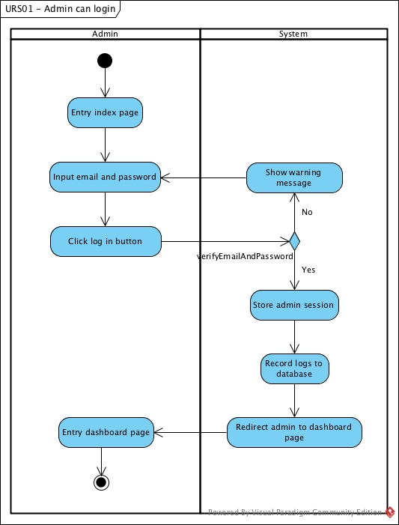

***Software requirement specification***

**SRS-01**: The system shall provides user interface to log in.  
**SRS-02**: The system shall verifies email and password.  
**SRS-03**: The system shall keeps user’s session.

**URS-02: Admin can logout from web server**

***Introduction***

Admin can log out from server. When the admin log out they can’t do anything with system

***Input***

Clicks log out button

***Data to display***

-

***Processing***

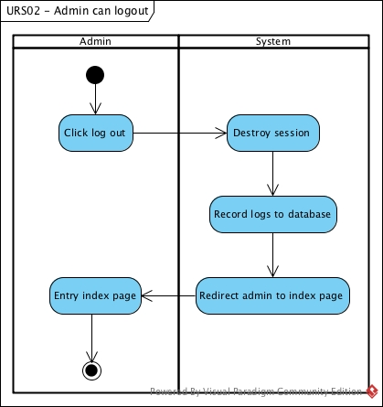

***Software requirement specification***

**SRS-05**: The system shall provides user interface to logout.  
**SRS-04**: The system shall destroys session.

**URS-03: Admin can add shop owner account**

***Introduction***

Admin can add or create shop owner account to system. Admin have to input shop owner information to the system. After admin completed add shop owner account, that account will allowed to log in to system.

***Input***

|  |  |  |  |
| --- | --- | --- | --- |
| **Input** | **Type** | **Example** | **Remarks** |
| Email | Varchar(45) | [coffeesmith@wap.com](mailto:coffeesmith@wap.com) |  |
| Password | Varchar(45) | 1234 |  |
| Confirm password | Varchar(45) | 1234 |  |
| Shop name | Varchar(100) | Coffee Smith |  |
| Address | Varchar(250) | 40 Nimmarnhemin Rd., T.Suthep, A.Muang,, Chiang Mai, 50200 |  |
| Phone number | Varchar(45) | 053784762 |  |
| Open and close time | Varchar(Text) | Everyday from 6.00AM – 10.00PM |  |
| Latitude | Decimal(12,10) | 18.7980341 |  |
| Longitude | Decimal(12,10) | 98.9665119 |  |
| Description | Varchar(Text) | Coffee smith is one of the best chilling place on Nimmanhemin road. We provide the best quality of coffee beans from Africa. |  |
| Area | Varchar(45) | Suthep |  |
| Image path | Varchar(250) | user_uploads/11/shop_images/coffeesmith.png |  |

***Data to display***

-

***Processing***

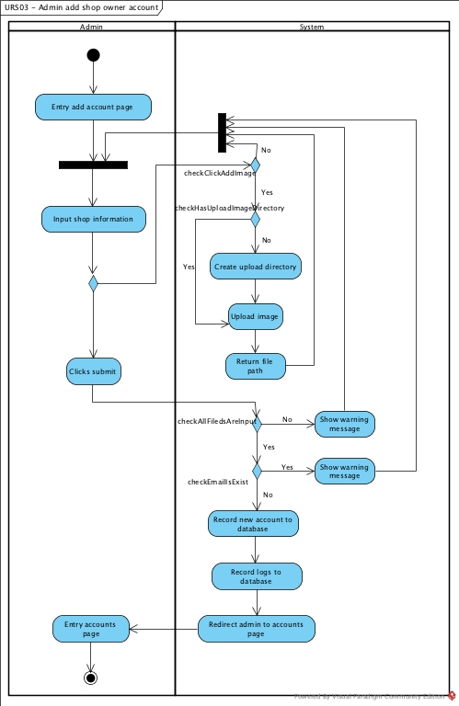

***Software requirement specification***

**SRS-06**: The system shall provides add account page to add new shop owner account.  
**SRS-07**: The system shall checks not available email in database.  
**SRS-26**: The system shall creates a directory for account  
**SRS-27**: The system shall creates a sub directory for profile  
**SRS-28**: The system shall upload image to directory.  
**SRS-29**: The system shall gets file path.  
**SRS-11**: The system shall checks all input required.  
**SRS-12**: The system shall records new account into database.